
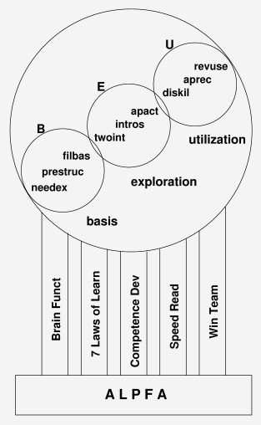
Accelerated
Learning Process
For Adults

Author: Benico van der Westhuizen

Table of Contents
License & Copyright 3
Introduction 4
Why speed up the rate of learning ? 4
MUG (Micro Users Guide): 5
Pillar 1: The Brain Functions 6
Introduction to Brain Functions 6
1.Visual 6
2.Auditory 6
3.Interpersonal 6
4.Intra-personal 6
5.Musical 6
6.Physical Motion 6
7.Mathematical 6
Pillar 1 Principles 7
Pillar 2: The Seven Laws of Learning 8
1) LEARNER 8
2) EXPECTATION 8
3) APPLICATION 9
4) RETENTION 9
5) NEED 10
6) EQUIP 10
7) REVIVE 10
Pillar 2 Principles 11
Pillar 3: Development of Competence 12
1) Elements of Competency Development 12
2) Application Domains 13
3) Competency vs Performance 13
4) The Competency Curve 14
Pillar 3 Principle 14
Pillar 4: Speed Reading 15
1) Overview 15
2) Preview 15
3) Read 15
4) Postview 15
5) Review 15
Pillar 4 Principles 15
Pillar 5: Winning Teams 16
Pillar 5 Principles 17
The Accelerated Learning PROCESS 17
BASIS 18
1) Determine the NEED & create Expectation [needex] 18
2) Present Visual STRUCTURE [prestruc] 18
3) Fill in the Basics [filbas] 18
EXPLORE 18
4) 2-Way Interaction [twoint] 18
5) Introspection [intros] 18
6) Application Activity [apact] 18
USE 19
7) Display Skills[diskil] 19
8) Applause & Recognition [aprec] 19
9) Review & Use[revuse] 19
Let me tell you a story ... 20

License & Copyright

ALPFA (Accelerated Learning Process For Adults) by Benico van der Westhuizen is licensed under a Creative Commons Attribution 3.0 Unported License. Based on a work at www.benico.co.za.

Introduction
ALPFA is about a process to speed up the learning rate of adults.
In other words: if you apply certain principles in the right order during the teaching process, ... it is possible to speed up the learning rate of “adults” (people over 6 years of age).

Why speed up the rate of learning ?
In order to survive in the information age ... we have to become a Continuous Learners.
and
after the age of six it becomes increasingly difficult to learn.
Thus ... in order to survive, people over 6 years of age has to find a way to accelerate their learning rate !
And this is precisely the origin and purpose of ALPFA - to find a Process to enable adults to learn at an accelerated rate.
The traditional system of academic training is not only SLOW and not effective - but also it does NOT provide for skills to sustain oneself in society.
The following comments are commonly found in literature :
- There is no more such a thing as Job security.
- Most people will experience 2 to 3 career changes during their life time.
- Employability is a function of your skills-base.
- The knowledge gained by a University degree will be obsolete within 10 years.
At "The Institute for the Achievement of Human Potential" , Glen Doman and his team are taking advantage of the phenomenal growth and learning potential of children between the ages zero to six years of age. The basic lesson to learn from their program is that after six years of age it becomes increasingly difficult to learn.

MUG (Micro Users Guide):
a) Cryptography:
The stuff in this document is cryptic ... because I respect your time, intelligence and ability to figure !
b) Presentation
ALPFA was derived in a 3 step approach:
-> Pillars -> Principles -> Process
- From 5 areas / (Pillars) certain Principles emerged;
- The Principles were isolated and condensed;
- and arranged into a Process.
Please use, apply, adopt and enjoy ALPFA.

Pillar 1: The Brain Functions
ALPFA is build on five pillars.
- Children's Brain Functions
- Seven Laws of the Learner
- Development of Competency
- Speed Reading
- Winning Teams

Introduction to Brain Functions
Educationalists discovered that there are several ways in which impacts are made on a childs brain during development (learning). These are:

Visual
Seeing pictures, watching others, etc.

Auditory
Hearing and listening to others and themselves.

Interpersonal
Interaction with the people around them.

Intra-personal
Private visualization, imagination (creativity), talking to self (resitation) investigating, feeling, smelling and tasting.

Musical
Teamwork, harmony, positioning & role, rhythms & poetry, music.

Physical Motion
Climbing, running, jumping, playing, not sitting still.

Mathematical
Order, structure, logic, flow of thought, deductive cause & result.
With these, also keep in mind the five sensory pathways to the brain:
- seeing
- hearing
- smelling
- tasting
- feeling
Although response of individuals will tend to show a preference for stimulation in certain areas, ALL areas have relevance in EVERY person. A very high impact can be achieved if ALL of these areas are stimulated during the learning process.
When we are learning or teaching we should try to stimulate all the above mentioned areas of the brain and try to use all the senses.

Pillar 1 Principles
What are the principles emerging from the Brain Functions ?:
During the learning process:
- Make use of visual
- as well as auditory stimulus
- Give opportunity for questions and discussions
- Give opportunity for dreaming and visualisation
- Make use of music, poetry, rhythm and rhymes
- Don't be passive, have some activity
- Make sure there is order, structure and a logical flow of contents and events

Pillar 2: The Seven Laws of Learning
(The following principles is from the WTB book: "The 7 Laws of the Learner" by Bruce Wilkenson.)

1) LEARNER
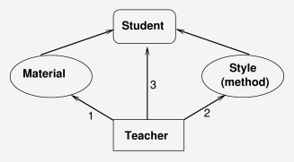
There are 3 Relationships that need to be managed:
Teacher vs -Method,
Teacher vs -Material,
Teacher vs -Students.
The Teacher is in control of the process ... and that implies that the Teacher is responsible for the outcome.
Teacher Success == ( is defined by) Student Success

2) EXPECTATION
Expect only the best from your students ... it will prove to be a self fulfilling prophesy. If you want to let someone know that you believe in him/her and that you expect they will achieve good things in life: create a positive expectation (about him/herself) by the following process:
- Observe: Your little child is rubbing some mud on the garden wall ...
- Describe: "I see that you are painting the wall."
- Feel: "It makes me feel proud to see that you care about our home."
- Believe: "I believe you will one day be a good steward of your own."
- Confirm: Give a hug and leave the mud for your friends to see.
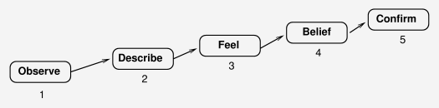

3) APPLICATION
The purpose of knowledge is application.
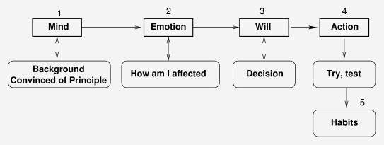
- Mental: Convinced about the Principles.
- Emotional: So what ? How does that affect me ?
- Will: I decide to give it a go.
- Physical: I try it, apply it, exercise it.
- Life Style: It has become a good habit.
The purpose of knowledge is application.

4) RETENTION
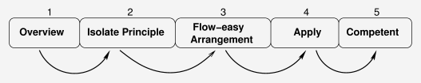
- Give an overview (prepare the ground).
- Isolate the principles (sow the seed kernels).
- Arrange the material in a logical, flowing, easy to remember sequence (water the ground).
- Apply the principles, exercise, train (the seed grow).
- Competence develop (the harvest is ready).

5) NEED
The need creation process:
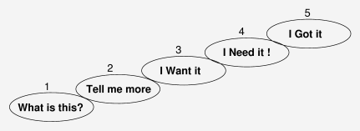
- Get attention:
what is this ?,
- Curiosity:
tell me more
- Benefits:
I want it,
- Tailor it:
I need it !
- Satisfy the need.

6) EQUIP
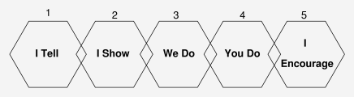
- This is the process of mentoring ...

7) REVIVE
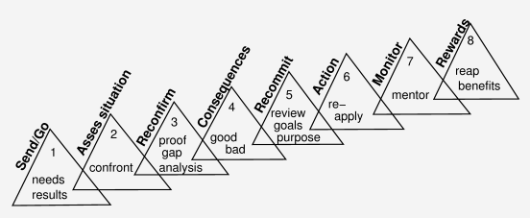
- Follow up, is it working, how are they doing, are they reproducing ?

Pillar 2 Principles
During the learning process:
- Make sure your method & style match the situation and the people
- Let them know that you believe in them and that you expect the best
- The purpose of knowledge is APPLICATION
- ONLY present the BASICS (principles) and make sure there is a logical easy flow
- Make sure they not only need it but that WANT it
- They need you to mentor and coach them
- Follow up - close the loop

Pillar 3: Development of Competence
When does experience count and when does a qualification count ? Why is it necessary to have a degree to become a manager ? These are two questions asked in many a corporation.
The answer is that neither qualification, nor experience but competence is the deciding factor.
Where does competence comes from ?

1) Elements of Competency Development
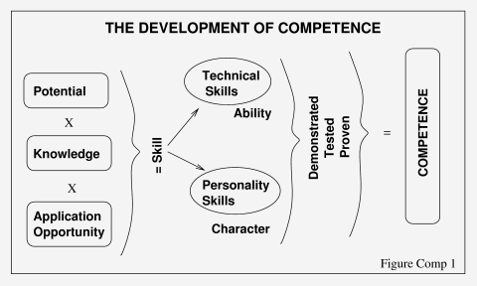
Knowledge (qualification) must be applied (experience) in order to develop skill. When skill is tested = competence.
Growth only happens when theory is put into practise. The two have to mix to get the reaction. When skill is demonstrated or tested, it gets classified as competence.

2) Application Domains
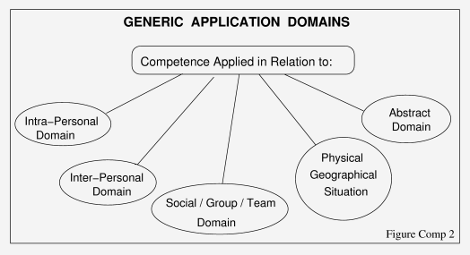
Competence can be applied in different areas:
The above diagram can be used to do a gap analyses of a skill in various application areas and focus development in the areas needed.

3) Competency vs Performance
Competence does not necessarily lead to Performance.
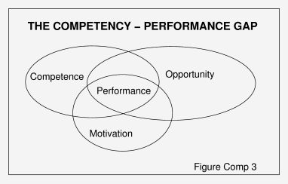

4) The Competency Curve
The skills development speed of individuals vary, not only according to their potential but also (or most importantly) according to their attitude and determination.
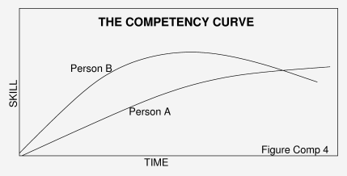
Person A is a Continuous Learner.
Person B has more potential and a quicker initial learning rate, but his skills are not grown and maintained over time.

Pillar 3 Principle
You have to APPLY knowledge if you want to develop skills, and you have to KEEP at it.

Pillar 4: Speed Reading
Even if you can't read 3000 to 5000 words per minute, you'll still find the 5 step approach applicable and making a lot of logical sense. This is the five step approach recommended for reading a book:
OVER . PRE . RE . POST . REV

1) Overview
Look for 1 second at each page in the book. This is to determine the Purpose of the book.

2) Preview
Look for 4 seconds at each page in the book. This is where your brain forms the 'gestahlt'of the book (the framework).

3) Read
As fast as you can, without retracing in any way building the meat onto the 'gestahlt'.

4) Postview
To fill in if you've missed and to clarify the main issues. Wrap up, Close up Summarise.

5) Review
Within two weeks time. This exercise your neural pathways to find the saved information.

Pillar 4 Principles
- Have a goal (purpose) in mind
- The brain needs a framework (structure / container) to associate (contain) the knowledge
- Go quickly - don't waste time, don't repeat the obvious, don't regress
- You have to wrap up, conclude, fill in the gaps
- Make sure the goal was achieved, audit it, follow it up.

Pillar 5: Winning Teams
What is the most booming business in the world today ? Sport ? . . . .If not ... where would you place sport ?
What is the magic circle that make sport so successful ?
- A group of people with certain skills organise themselves into a TEAM and engage in an activity.
- They have a coach to organise and harmonise them.
- The big day is the day of the game when the skills are tested and score is kept.
- On recognition of the results Applause is given.
- This thrill of winning serves as motivation to go out and improve the skills.
- The partisipants and spectators develop a passion for the sport and the circle repeats.
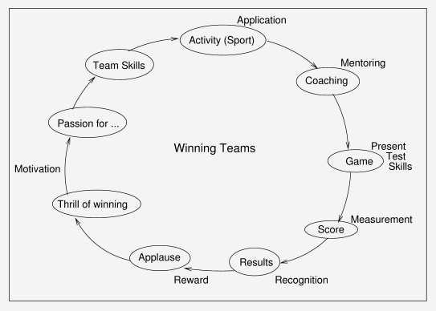
Which of these elements are absent from our learning experience today ?

Pillar 5 Principles
Make use of games or activities where people experience teamwork, the thrill of winning and the opportunity to present skills. Create an environment where learners can be Cheered, Coached and Applaused.

The Accelerated Learning PROCESS
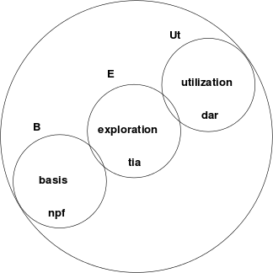
This chapter contains an arrangement of some of the Principles into a process with three phases:
- the formation of a theoretical basis
- an exploration of what we just heard (this is the actual learning process)
- an utilisation phase (this is to test whether skills were acquired and to motivate the use of it)
Please feel free to change this to suit YOUR needs.

BASIS

1) Determine the NEED & create Expectation [needex]
This is why we do it, the reason, the goal, the overview. This is what I'm going to benefit from this. (Where are we going ?)

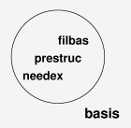
2) Present Visual STRUCTURE [prestruc]
This is the road map, mind map, the structure used to put content into context. (How are we going to get there ?) Use pictures, diagrams, brainmaps, outlines ... be creative.

3) Fill in the Basics [filbas]
Fill in the basics, let them deduct (discover) the details. Respect their time and their intelligence. Use repetition but don't repeat the obvious over and over. Don't read from the book, they can do it themselves. Cover the basic principles and concepts. Lead them to discovering the details. This is the content, the meat. Make it easy for them to remember - harmonize it, - keep it short, - tell a story.

EXPLORE

4) 2-Way Interaction [twoint]
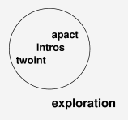
Give opportunity for questions & discussions. Man is a social being. Much more can be learned from the group than from one lecturer. Use this enormous Intrapersonal and Group learning potential to clarify the principles and to plant the concepts.

5) Introspection [intros]
Give each person time for his/her ownd thoughts, plans, dreams, and visions. Time to make it their own, time to use their imagination.

6) Application Activity [apact]
DO Something ! APPLY the theory. Have some action. Play a game. You've Told them ... now Show them ... and then let They do it. Just don't sit still. Remember: You must train trainers.

USE

7) Display Skills[diskil]
Give or make an opportunity for the learners (best in team format) to display, present, test and exercise their skills. Make a drama, have a competition, enjoy it. This creates an opportunity for the next step ... Nothing motivates like applause.

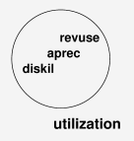
8) Applause & Recognition [aprec]
Let them feel good about their achievements. You want them to apply the stuff. Motivate them to do so. They have to believe in themselves in order to be successful. First You show them that You believe in them.

9) Review & Use[revuse]
Don't just leave it there ... Follow up ! How is it going, how are you doing, is it still working, have you been training others ?

Let me tell you a story ...
Arthur knew the sunken ship was off the shore of Long Island. He has never been so excited in his life ! [needex]
The magnetic satellite images they acquired were extremely valuable in planning the recovery. [prestruct].
Consultation with the salvage company helped them to include all the basic stuff they would need for the operation. [filbas].
The team had much discussion about the feasibility of different recovery methods [twoint] .
All of them dreamt about this adventure for months. [intros]
At least now the are on their way !
[apact]
When they recover the old ship [diskil] it will be covered by international television stations all over the world [aprec] .
This can only open the door to more lucrative excursions in the future.
[revuse]

