
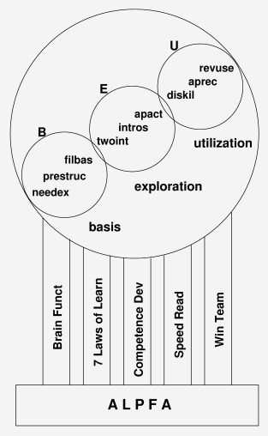
Accelerated
Learning Process
For Adults

Author: Benico van der Westhuizen

Table of Contents
License & Copyright 3
Efficient Learning: WHY? 4
Why? 4
The PROCESS 5
BASIS 5
1) Determine the NEED & create Expectation [needex] 5
2) Present Visual STRUCTURE [prestruc] 5
3) Fill in the Basics [filbas] 5
EXPLORE 6
4) 2-Way Interaction [twoint] 6
5) Introspection [intros] 6
6) Application Activity [apact] 6
USE 6
7) Display Skills[diskil] 6
8) Applause & Recognition [aprec] 6
9) Review & Use[revuse] 7
Let me tell you a story ... 8
ALPFA is build on five pillars. 9
Pillar 1: Brain Functions 10
1. Visual 10
2. Auditory 10
3. Interpersonal 10
4. Intra-personal 10
5. Musical 10
6. Physical Motion 10
7. Mathematical 10
Pillar 1 Principles 11
Pillar 2: Seven Laws of Learning 11
1) LEARNER 11
2) EXPECTATION 12
3) APPLICATION 12
4) RETENTION 13
5) NEED 13
6) EQUIP 14
7) REVIVE 14
Pillar 2 Principles 14
Pillar 3: Development of Competence 16
1) Elements of Competency Development 16
2) Application Domains 17
3) Competency vs Performance 17
4) The Competency Curve 18
Pillar 3 Principle 19
Pillar 4: Speed Reading 20
1) Overview 20
2) Preview 20
3) Read 20
4) Postview 20
5) Review 20
Pillar 4 Principles 20
Pillar 5: Winning Teams 21
Pillar 5 Principles 22

License & Copyright

ALPFA (Accelerated Learning Process For Adults) by Benico van der Westhuizen is licensed under a Creative Commons Attribution 3.0 Unported License. Based on a work at www.benico.co.za.

WHY Acellerate Learning ?
Apparently children’s brains develop connections faster in the first five years than at any other time in their lives.
But what happens after 5 years of age?
And what about adults?
ALPFA is about a process to speed up the learning rate of adults.
If you apply certain principles in the right order during the teaching process, it should be possible to speed up the learning rate.

Why?
In order to survive in the information age we have to become a Continuous Learners
and
after the age of six, human learning rates seem to slow down significantly
so
in order to survive we have to find ways to accelerate our learning rate.
ALPFA is an attempt to find a process for accelerating the learning rate of adults. This contrast with the traditional system of academic training which tends to be slow, inefficient and not equipping people with real-life practical skills.

The PROCESS
The proposed process consists of three phases, each with three elements.
The foundation phase consists of expectation, structure and principles. In the exploration phase we allow for two-way interaction, active application and introspection. The utilisation stage caters for skills demonstration, applause and revision.

Foundation Phase 1: benefit
The very first step is to Determine the NEED and Create Expectation of what is to be achieved. We establish destination (goal), the reason (why) and we sell the benefit.

Foundation Phase 2: structure
Present Structure: nothing can be organised without structure. Also, memory works by association. A skeleton is needed to organise and associate our content into context.
Visual structures like flow diagrams, brainmaps, models, road maps and outlines help to place the muscles, and organs in the right place in the body.

Foundation Phase 3: principles
Basic Core Principles (laws) are governing each area of life. We only have to introduce the applicable principles, without detail. Respect people's right to discover the details for themselves. It will be an adventure never forgotten.
Story telling is an excellent tool to make it easy to undeerstand principles and to remember things.

Exploration Phase 1: group learn
Man is a pact animal. Group learning is a powerful tool to form Understanding and shape Concepts. Allow free exploration, let them answer their own questions, direct the flow but don't try to control things too much.

Exploration Phase 2: play
Now put the theory into action. Develop skills by actively applying the concepts by creating scenarios, doing simulations, role playing and games.

Exploration Phase 3: dream
After action satisfaction. Give each person time for introspection. Their own thoughts, plans, dreams, and visions.

Competence Phase 1: show
The capstone is an opportunity to display, present, test and exercise the skills in a safe environment. This can be a test, project, presentation, result or any other practical deliverable item that must be produced.

Competence Phase 2: applause
Recognition for achievements ignites passion and purpose in people. Applause is like a drug. People will continue to make use of what they have learned when they believe in themselves and are recognised.

Competence Phase 3: follow up
So don't just leave it there, follow up ! How is it going, how are you doing, is it still working, have you been training others ?
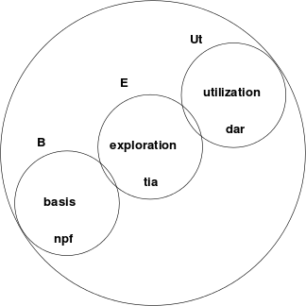

Let me tell you a story ...
Arthur knew the sunken ship was off the shore of Long Island. He has never been so excited in his life ! [needex]
The magnetic satellite images they acquired were extremely valuable in planning the recovery. [prestruct].
Consultation with the salvage company helped them to include all the basic stuff they would need for the operation. [filbas].
The team had much discussion about the feasibility of different recovery methods [twoint] .
All of them dreamt about this adventure for months. [intros]
At least now the are on their way !
[apact]
When they recover the old ship [diskil] it will be covered by international television stations all over the world [aprec] .
This can only open the door to more lucrative excursions in the future.
[revuse]

ALPFA is build on five pillars.
- Children's Brain Functions
- Seven Laws of the Learner
- Development of Competency
- Speed Reading
- Winning Teams

Pillar 1: Brain Functions
Educationalists discovered that there are several ways in which impacts are made on a childs brain during development (learning). These are:

Visual
Seeing pictures, watching others, etc.

Auditory
Hearing and listening to others and themselves.

Interpersonal
Interaction with the people around them.

Intra-personal
Private visualization, imagination (creativity), talking to self (resitation) investigating, feeling, smelling and tasting.

Musical
Teamwork, harmony, positioning & role, rhythms & poetry, music.

Physical Motion
Climbing, running, jumping, playing, not sitting still.

Mathematical
Order, structure, logic, flow of thought, deductive cause & result.
With these, also keep in mind the five sensory pathways to the brain:
- seeing
- hearing
- smelling
- tasting
- feeling
Although response of individuals will tend to show a preference for stimulation in certain areas, ALL areas have relevance in EVERY person. A very high impact can be achieved if ALL of these areas are stimulated during the learning process.
When we are learning or teaching we should try to stimulate all the above mentioned areas of the brain and try to use all the senses.

Pillar 1 Principles
What are the principles emerging from the Brain Functions ?:
During the learning process:
- Make use of visual
- as well as auditory stimulus
- Give opportunity for questions and discussions
- Give opportunity for dreaming and visualisation
- Make use of music, poetry, rhythm and rhymes
- Don't be passive, have some activity
- Make sure there is order, structure and a logical flow of contents and events

Pillar 2: Seven Laws of Learning
(The following principles is from the WTB book: "The 7 Laws of the Learner" by Bruce Wilkenson.)

1) LEARNER
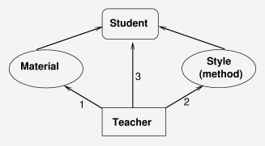
There are 3 Relationships that need to be managed:
Teacher vs -Method,
Teacher vs -Material,
Teacher vs -Students.
The Teacher is in control of the process ... and that implies that the Teacher is responsible for the outcome.
Teacher Success == ( is defined by) Student Success

2) EXPECTATION
Expect only the best from your students ... it will prove to be a self fulfilling prophesy. If you want to let someone know that you believe in him/her and that you expect they will achieve good things in life: create a positive expectation (about him/herself) by the following process:
- Observe: Your little child is rubbing some mud on the garden wall ...
- Describe: "I see that you are painting the wall."
- Feel: "It makes me feel proud to see that you care about our home."
- Believe: "I believe you will one day be a good steward of your own."
- Confirm: Give a hug and leave the mud for your friends to see.
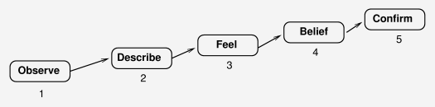

3) APPLICATION
The purpose of knowledge is application.
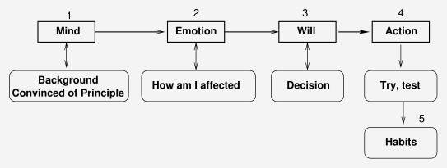
- Mental: Convinced about the Principles.
- Emotional: So what ? How does that affect me ?
- Will: I decide to give it a go.
- Physical: I try it, apply it, exercise it.
- Life Style: It has become a good habit.
The purpose of knowledge is application.

4) RETENTION
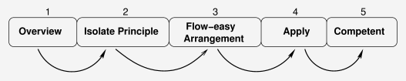
- Give an overview (prepare the ground).
- Isolate the principles (sow the seed kernels).
- Arrange the material in a logical, flowing, easy to remember sequence (water the ground).
- Apply the principles, exercise, train (the seed grow).
- Competence develop (the harvest is ready).

5) NEED
The need creation process:
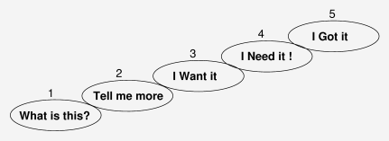
- Get attention:
what is this ?,
- Curiosity:
tell me more
- Benefits:
I want it,
- Tailor it:
I need it !
- Satisfy the need.

6) EQUIP
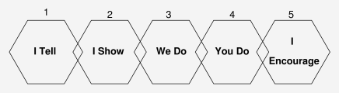
- This is the process of mentoring ...

7) REVIVE
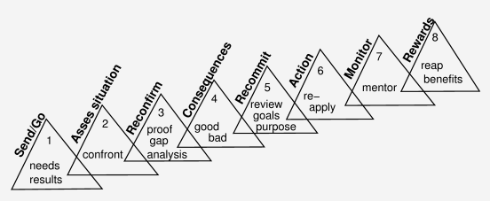
- Follow up, is it working, how are they doing, are they reproducing ?

Pillar 2 Principles
During the learning process:
- Make sure your method & style match the situation and the people
- Let them know that you believe in them and that you expect the best
- The purpose of knowledge is APPLICATION
- ONLY present the BASICS (principles) and make sure there is a logical easy flow
- Make sure they not only need it but that WANT it
- They need you to mentor and coach them
- Follow up - close the loop

Pillar 3: Development of Competence
When does experience count and when does a qualification count ? Why is it necessary to have a degree to become a manager ? These are two questions asked in many a corporation.
The answer is that neither qualification, nor experience but competence is the deciding factor.
Where does competence comes from ?

1) Elements of Competency Development
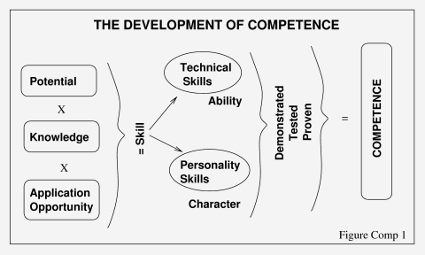
Knowledge (qualification) must be applied (experience) in order to develop skill. When skill is tested = competence.
Growth only happens when theory is put into practise. The two have to mix to get the reaction. When skill is demonstrated or tested, it gets classified as competence.

2) Application Domains
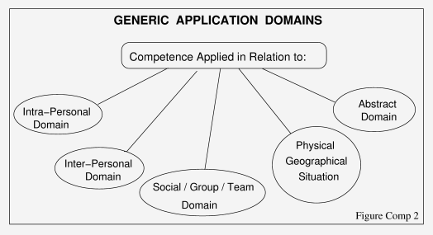
Competence can be applied in different areas:
The above diagram can be used to do a gap analyses of a skill in various application areas and focus development in the areas needed.

3) Competency vs Performance
Competence does not necessarily lead to Performance.
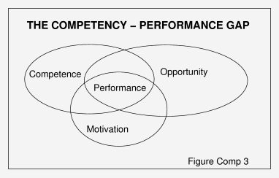

4) The Competency Curve
The skills development speed of individuals vary, not only according to their potential but also (or most importantly) according to their attitude and determination.
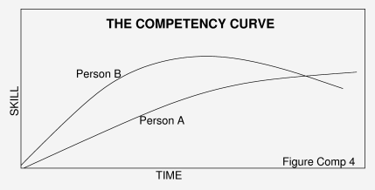
Person A is a Continuous Learner.
Person B has more potential and a quicker initial learning rate, but his skills are not grown and maintained over time.

Pillar 3 Principle
You have to APPLY knowledge if you want to develop skills, and you have to KEEP at it.

Pillar 4: Speed Reading
Even if you can't read 3000 to 5000 words per minute, you'll still find the 5 step approach applicable and making a lot of logical sense. This is the five step approach recommended for reading a book:
OVER . PRE . RE . POST . REV

1) Overview
Look for 1 second at each page in the book. This is to determine the Purpose of the book.

2) Preview
Look for 4 seconds at each page in the book. This is where your brain forms the 'gestahlt'of the book (the framework).

3) Read
As fast as you can, without retracing in any way building the meat onto the 'gestahlt'.

4) Postview
To fill in if you've missed and to clarify the main issues. Wrap up, Close up Summarise.

5) Review
Within two weeks time. This exercise your neural pathways to find the saved information.

Pillar 4 Principles
- Have a goal (purpose) in mind
- The brain needs a framework (structure / container) to associate (contain) the knowledge
- Go quickly - don't waste time, don't repeat the obvious, don't regress
- You have to wrap up, conclude, fill in the gaps
- Make sure the goal was achieved, audit it, follow it up.

Pillar 5: Winning Teams
What is the most booming business in the world today ? Sport ? . . . .If not ... where would you place sport ?
What is the magic circle that make sport so successful ?
- A group of people with certain skills organise themselves into a TEAM and engage in an activity.
- They have a coach to organise and harmonise them.
- The big day is the day of the game when the skills are tested and score is kept.
- On recognition of the results Applause is given.
- This thrill of winning serves as motivation to go out and improve the skills.
- The partisipants and spectators develop a passion for the sport and the circle repeats.
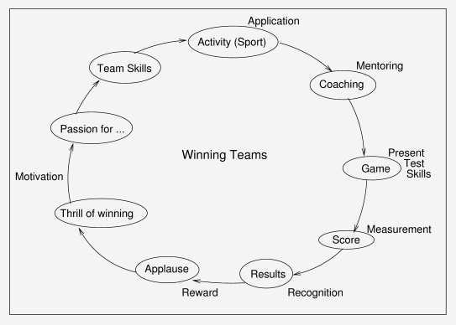
Which of these elements are absent from our learning experience today ?

Pillar 5 Principles
Make use of games or activities where people experience teamwork, the thrill of winning and the opportunity to present skills. Create an environment where learners can be Cheered, Coached and Applaused.

